GOOGLE SQL Interview Questions
Q. We have the table three table: Product, Customer, and Sales

Product:
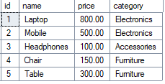
Customer:
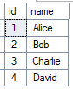
Sales:
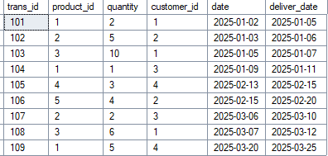

- Write a SQL Query to find top Products by Week (Week Starts on Thursday)
Output:
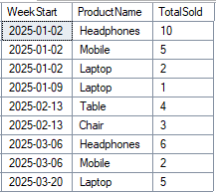
- Write a SQL Query to find top Products by Year & Month.
